Create Table Exercise

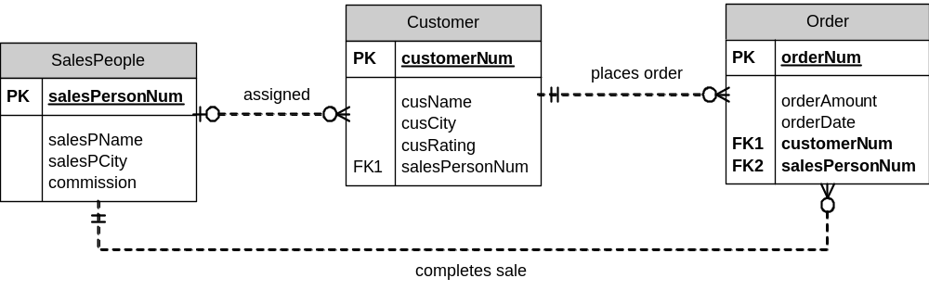

Create a table “SalesPeople” with the following columns:
- salesPersonNum is a four digit integer that uniquely identifies each sales person
- salesPName is a character type, with up to 15 characters – all sales people will have a value set for salesName.
- salesPCity is a character type, with up to 15 characters – it may be left blank
- commission is a decimal type – with up to 2 decimal places – it may be left blank – the default value is 0.10 – must contain a value less than 1 but greater than 0.

Sample data:
salesPersonNum | salesPName | salesPCity | commission
1001 | Peel | London | .12
1002 | Serres | San Jose | .13
1004 | Motika | London | .11
1007 | Rifkin | Barcelona | .15
1003 | Axelrod | New York | .10

Create a table “Customer” with the following:
- customerNum is a four digit integer that uniquely identifies each customer
- cusName is a character type, with up to 15 characters – must have a value
- cusCity is a character type, with up to 15 characters – may be blank
- cusRating is a three-digit integer type – may be blank
- salesPersonNum will refer to a value in the SalesPeople table – it may be blank.

Sample data:
CustomerNum | cusName | cusCity | cusRating | salesPersonNum
2001 | Hoffman | London | 100 | 1001
2002 | Giovanni | Rome | 200 | 1003
2003 | Liu | San Jose | 200 | 1002
2004 | Grass | Berlin | 300 | 1002
2006 | Clemens | London |  | 1001
2008 | Cisneros | San Jose | 300 | 1007
2007 | Pereira | Rome | 100 | 1004

Create a table “Orders” with the following:
(Note: The ERD is incorrectly marked, Order should be Orders)
- orderNum is a four digit integer that uniquely identifies each order
- orderAmount is a fixed-point number with two decimal places and up to 9 digits in total – must have a value
- orderDate is a date type – must have a value
- customerNum is a reference to the customer that placed this order – must have a value
- salesPersonNum is a reference to the sales person who helped with this order – the salesPersonNum here may be different than the salesPersonNum assigned for the customer. salesPersonNum may be blank

Sample data:
orderNum | orderAmount | orderDate | customerNum | salesPersonNum
3001 | 18.69 | 10/03/2000 | 2008 | 1007
3003 | 767.19 | 10/03/2000 | 2001 | 1001
3002 | 1900.10 | 10/03/2000 | 2007 | 1004
3005 | 5160.45 | 10/03/2000 | 2003 | 1002
3006 | 1098.16 | 10/03/2000 | 2008 | 1007
3009 | 1713.23 | 10/04/2000 | 2002 | 1003
3007 | 75.75 | 10/04/2000 | 2004 | 1002
3008 | 4723.00 | 10/05/2000 | 2006 | 1001
3010 | 1309.95 | 10/06/2000 | 2004 | 1002
3011 | 9891.88 | 10/06/2000 | 2006 | 1001

Alter Table

- Remove the commission column from SalesPeople.
- Add a column maxSale to SalesPeople that has a default of 0 and can store a maximum value of 999,999.99
- Allow salesPName to be blank.
- Add a default date of January 1st, 2012 for OrderDate.

